Evolve Edge ERD
I’ve split it into:
- Core identity and tenancy
- Compliance and analysis workflow
- Reporting and audit
- Implementation notes

Evolve Edge ERD — Developer Ready
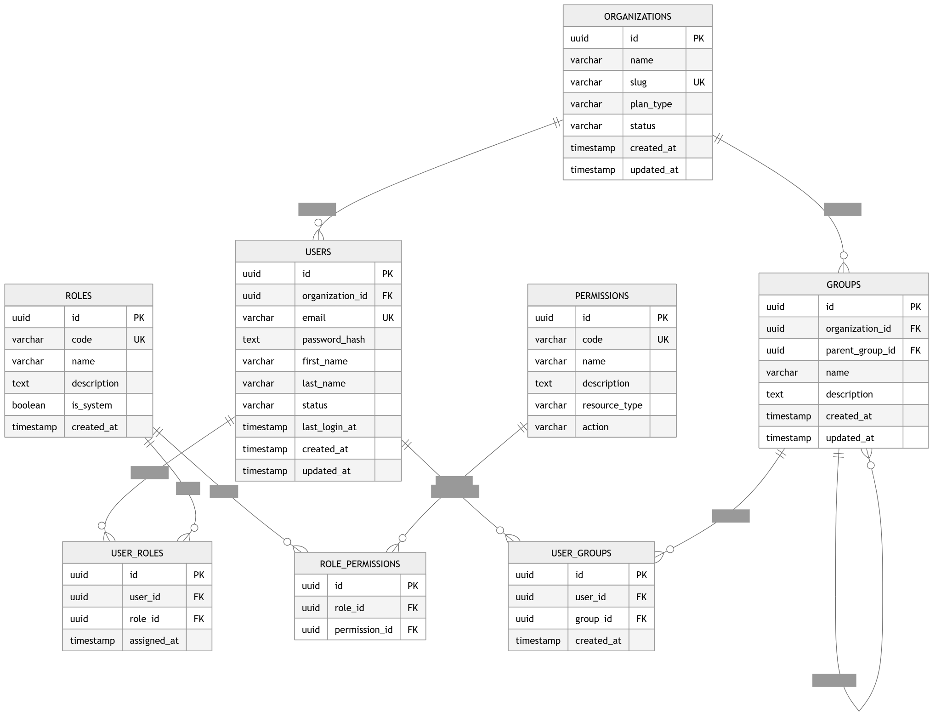

1) Core Identity, Tenant, and Access Model
erDiagram
ORGANIZATIONS {
uuid id PK
varchar name
varchar slug UK
varchar plan_type
varchar status
timestamp created_at
timestamp updated_at
}

USERS {
uuid id PK
uuid organization_id FK
varchar email UK
text password_hash
varchar first_name
varchar last_name
varchar status
timestamp last_login_at
timestamp created_at
timestamp updated_at
}

ROLES {
uuid id PK
varchar code UK
varchar name
text description
boolean is_system
timestamp created_at
}

PERMISSIONS {
uuid id PK
varchar code UK
varchar name
text description
varchar resource_type
varchar action
}

USER_ROLES {
uuid id PK
uuid user_id FK
uuid role_id FK
timestamp assigned_at
}

ROLE_PERMISSIONS {
uuid id PK
uuid role_id FK
uuid permission_id FK
}

GROUPS {
uuid id PK
uuid organization_id FK
uuid parent_group_id FK
varchar name
text description
timestamp created_at
timestamp updated_at
}

USER_GROUPS {
uuid id PK
uuid user_id FK
uuid group_id FK
timestamp created_at
}

ORGANIZATIONS ||--o{ USERS : contains
ORGANIZATIONS ||--o{ GROUPS : contains
GROUPS ||--o{ GROUPS : parent_of
USERS ||--o{ USER_ROLES : assigned
ROLES ||--o{ USER_ROLES : maps
ROLES ||--o{ ROLE_PERMISSIONS : grants
PERMISSIONS ||--o{ ROLE_PERMISSIONS : includes
USERS ||--o{ USER_GROUPS : belongs_to
GROUPS ||--o{ USER_GROUPS : contains

2) Compliance Content, Documents, and Assessment Workflow
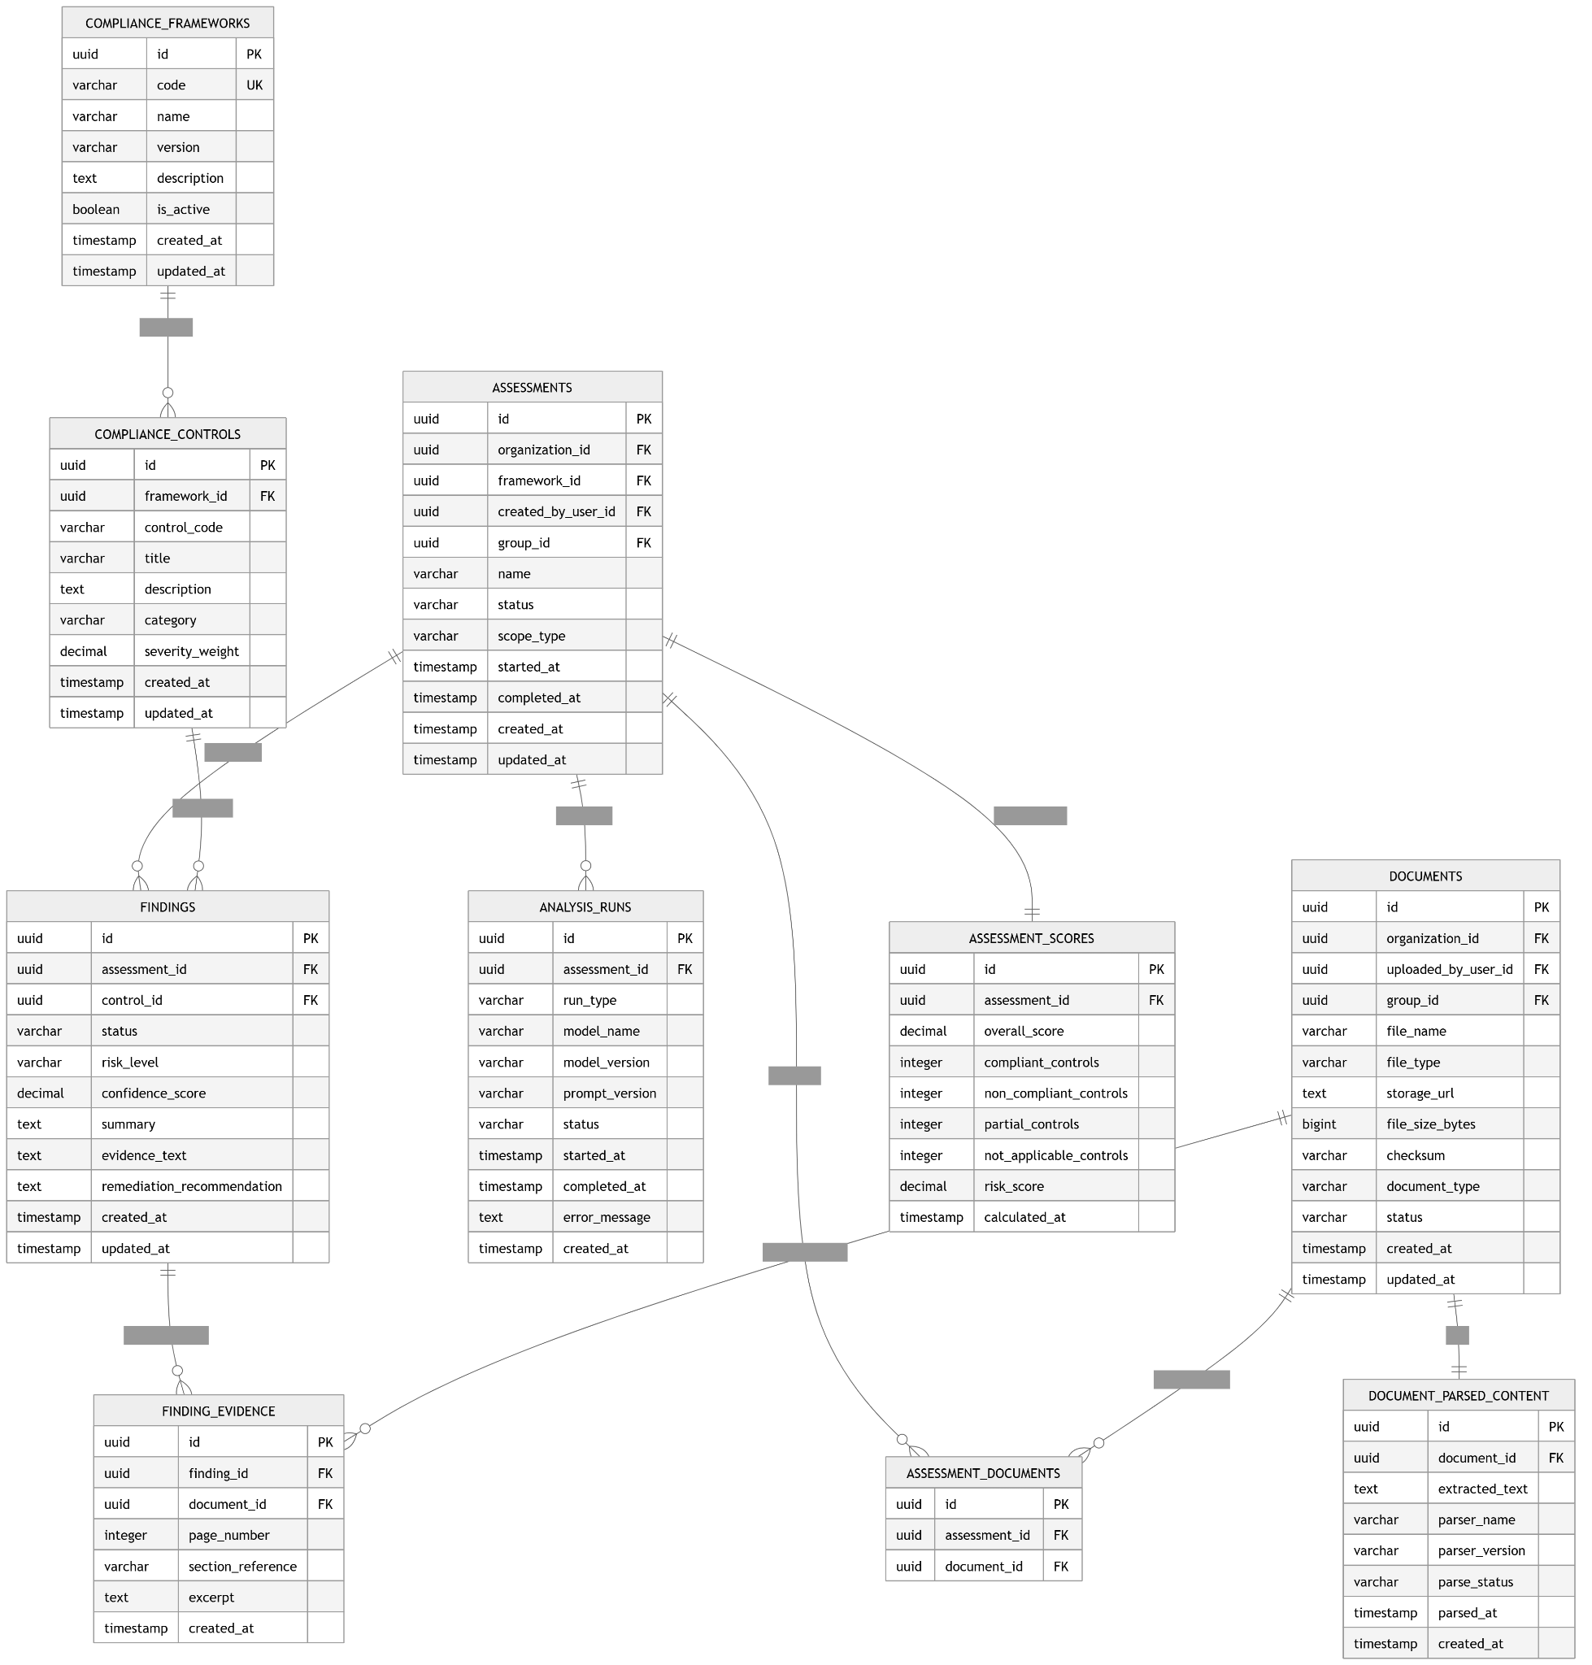
erDiagram
COMPLIANCE_FRAMEWORKS {
uuid id PK
varchar code UK
varchar name
varchar version
text description
boolean is_active
timestamp created_at
timestamp updated_at
}

COMPLIANCE_CONTROLS {
uuid id PK
uuid framework_id FK
varchar control_code
varchar title
text description
varchar category
decimal severity_weight
timestamp created_at
timestamp updated_at
}

DOCUMENTS {
uuid id PK
uuid organization_id FK
uuid uploaded_by_user_id FK
uuid group_id FK
varchar file_name
varchar file_type
text storage_url
bigint file_size_bytes
varchar checksum
varchar document_type
varchar status
timestamp created_at
timestamp updated_at
}

DOCUMENT_PARSED_CONTENT {
uuid id PK
uuid document_id FK
text extracted_text
varchar parser_name
varchar parser_version
varchar parse_status
timestamp parsed_at
timestamp created_at
}

ASSESSMENTS {
uuid id PK
uuid organization_id FK
uuid framework_id FK
uuid created_by_user_id FK
uuid group_id FK
varchar name
varchar status
varchar scope_type
timestamp started_at
timestamp completed_at
timestamp created_at
timestamp updated_at
}

ASSESSMENT_DOCUMENTS {
uuid id PK
uuid assessment_id FK
uuid document_id FK
}

ANALYSIS_RUNS {
uuid id PK
uuid assessment_id FK
varchar run_type
varchar model_name
varchar model_version
varchar prompt_version
varchar status
timestamp started_at
timestamp completed_at
text error_message
timestamp created_at
}

FINDINGS {
uuid id PK
uuid assessment_id FK
uuid control_id FK
varchar status
varchar risk_level
decimal confidence_score
text summary
text evidence_text
text remediation_recommendation
timestamp created_at
timestamp updated_at
}

FINDING_EVIDENCE {
uuid id PK
uuid finding_id FK
uuid document_id FK
integer page_number
varchar section_reference
text excerpt
timestamp created_at
}

ASSESSMENT_SCORES {
uuid id PK
uuid assessment_id FK
decimal overall_score
integer compliant_controls
integer non_compliant_controls
integer partial_controls
integer not_applicable_controls
decimal risk_score
timestamp calculated_at
}

COMPLIANCE_FRAMEWORKS ||--o{ COMPLIANCE_CONTROLS : contains
DOCUMENTS ||--|| DOCUMENT_PARSED_CONTENT : has
ASSESSMENTS ||--o{ ASSESSMENT_DOCUMENTS : includes
DOCUMENTS ||--o{ ASSESSMENT_DOCUMENTS : attached_to
ASSESSMENTS ||--o{ ANALYSIS_RUNS : executes
ASSESSMENTS ||--o{ FINDINGS : produces
COMPLIANCE_CONTROLS ||--o{ FINDINGS : evaluates
FINDINGS ||--o{ FINDING_EVIDENCE : supported_by
DOCUMENTS ||--o{ FINDING_EVIDENCE : sourced_from
ASSESSMENTS ||--|| ASSESSMENT_SCORES : summarizes

3) Reporting and Audit
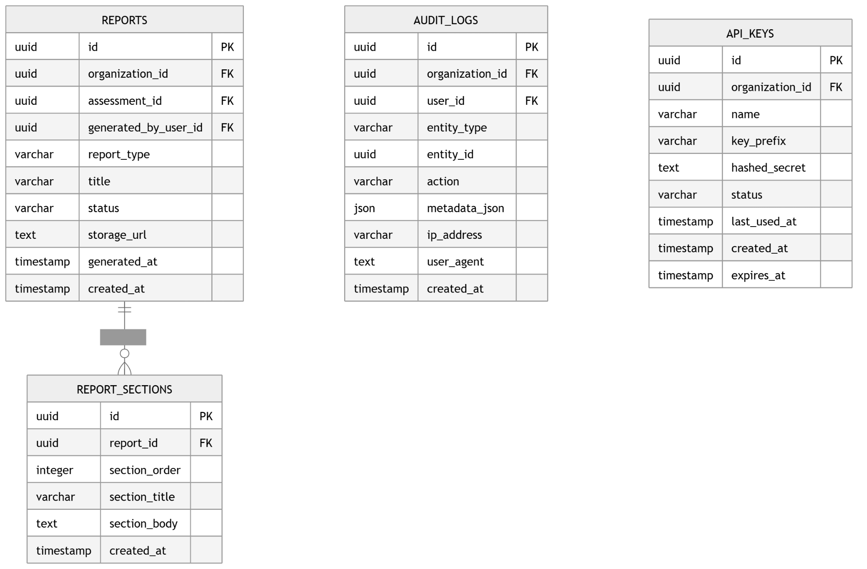
erDiagram
REPORTS {
uuid id PK
uuid organization_id FK
uuid assessment_id FK
uuid generated_by_user_id FK
varchar report_type
varchar title
varchar status
text storage_url
timestamp generated_at
timestamp created_at
}

REPORT_SECTIONS {
uuid id PK
uuid report_id FK
integer section_order
varchar section_title
text section_body
timestamp created_at
}

AUDIT_LOGS {
uuid id PK
uuid organization_id FK
uuid user_id FK
varchar entity_type
uuid entity_id
varchar action
json metadata_json
varchar ip_address
text user_agent
timestamp created_at
}

API_KEYS {
uuid id PK
uuid organization_id FK
varchar name
varchar key_prefix
text hashed_secret
varchar status
timestamp last_used_at
timestamp created_at
timestamp expires_at
}

REPORTS ||--o{ REPORT_SECTIONS : contains

4) Full Cross-Domain ERD
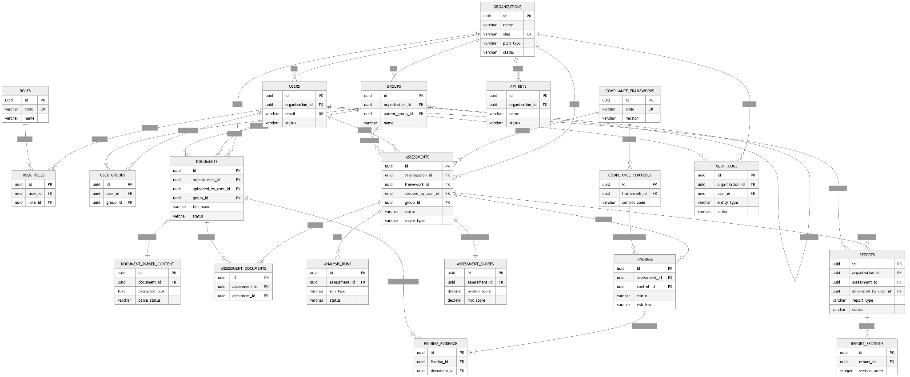
Main cross-table relationships during implementation.
erDiagram
ORGANIZATIONS {
uuid id PK
varchar name
varchar slug UK
varchar plan_type
varchar status
}

USERS {
uuid id PK
uuid organization_id FK
varchar email UK
varchar status
}

GROUPS {
uuid id PK
uuid organization_id FK
uuid parent_group_id FK
varchar name
}

ROLES {
uuid id PK
varchar code UK
varchar name
}

USER_ROLES {
uuid id PK
uuid user_id FK
uuid role_id FK
}

USER_GROUPS {
uuid id PK
uuid user_id FK
uuid group_id FK
}

COMPLIANCE_FRAMEWORKS {
uuid id PK
varchar code UK
varchar version
}

COMPLIANCE_CONTROLS {
uuid id PK
uuid framework_id FK
varchar control_code
}

DOCUMENTS {
uuid id PK
uuid organization_id FK
uuid uploaded_by_user_id FK
uuid group_id FK
varchar file_name
varchar status
}

DOCUMENT_PARSED_CONTENT {
uuid id PK
uuid document_id FK
text extracted_text
varchar parse_status
}

ASSESSMENTS {
uuid id PK
uuid organization_id FK
uuid framework_id FK
uuid created_by_user_id FK
uuid group_id FK
varchar status
varchar scope_type
}

ASSESSMENT_DOCUMENTS {
uuid id PK
uuid assessment_id FK
uuid document_id FK
}

ANALYSIS_RUNS {
uuid id PK
uuid assessment_id FK
varchar run_type
varchar status
}

FINDINGS {
uuid id PK
uuid assessment_id FK
uuid control_id FK
varchar status
varchar risk_level
}

FINDING_EVIDENCE {
uuid id PK
uuid finding_id FK
uuid document_id FK
}

ASSESSMENT_SCORES {
uuid id PK
uuid assessment_id FK
decimal overall_score
decimal risk_score
}

REPORTS {
uuid id PK
uuid organization_id FK
uuid assessment_id FK
uuid generated_by_user_id FK
varchar report_type
varchar status
}

REPORT_SECTIONS {
uuid id PK
uuid report_id FK
integer section_order
}

AUDIT_LOGS {
uuid id PK
uuid organization_id FK
uuid user_id FK
varchar entity_type
varchar action
}

API_KEYS {
uuid id PK
uuid organization_id FK
varchar name
varchar status
}

ORGANIZATIONS ||--o{ USERS : has
ORGANIZATIONS ||--o{ GROUPS : has
GROUPS ||--o{ GROUPS : parent_of

USERS ||--o{ USER_ROLES : assigned
ROLES ||--o{ USER_ROLES : mapped
USERS ||--o{ USER_GROUPS : belongs_to
GROUPS ||--o{ USER_GROUPS : contains

COMPLIANCE_FRAMEWORKS ||--o{ COMPLIANCE_CONTROLS : defines

ORGANIZATIONS ||--o{ DOCUMENTS : owns
USERS ||--o{ DOCUMENTS : uploads
GROUPS ||--o{ DOCUMENTS : scoped_to
DOCUMENTS ||--|| DOCUMENT_PARSED_CONTENT : parsed_as

ORGANIZATIONS ||--o{ ASSESSMENTS : owns
COMPLIANCE_FRAMEWORKS ||--o{ ASSESSMENTS : used_in
USERS ||--o{ ASSESSMENTS : creates
GROUPS ||--o{ ASSESSMENTS : scoped_to

ASSESSMENTS ||--o{ ASSESSMENT_DOCUMENTS : includes
DOCUMENTS ||--o{ ASSESSMENT_DOCUMENTS : attached

ASSESSMENTS ||--o{ ANALYSIS_RUNS : runs
ASSESSMENTS ||--o{ FINDINGS : produces
COMPLIANCE_CONTROLS ||--o{ FINDINGS : evaluated_against
FINDINGS ||--o{ FINDING_EVIDENCE : supported_by
DOCUMENTS ||--o{ FINDING_EVIDENCE : referenced_from
ASSESSMENTS ||--|| ASSESSMENT_SCORES : summarized_by

ASSESSMENTS ||--o{ REPORTS : generates
USERS ||--o{ REPORTS : generates
REPORTS ||--o{ REPORT_SECTIONS : contains

ORGANIZATIONS ||--o{ AUDIT_LOGS : records
USERS ||--o{ AUDIT_LOGS : performs
ORGANIZATIONS ||--o{ API_KEYS : owns

Implementation Notes

A. Tenant isolation
Every business-owned row should be constrained by organization_id, either directly or indirectly.
Direct tenant tables
- users
- groups
- documents
- assessments
- reports
- audit_logs
- api_keys
Indirect tenant tables
- document_parsed_content → document
- assessment_documents → assessment/document
- analysis_runs → assessment
- findings → assessment
- finding_evidence → finding/document
- assessment_scores → assessment
- report_sections → report
Developer rule:
- every query in the app should filter by org boundary
- never trust client-submitted organization IDs without server-side validation

B. Role model for MVP
For the MVP, use seeded system roles:
- super_admin
- org_admin
- manager
- analyst
- viewer
Recommended implementation:
- keep roles, permissions, and role_permissions in schema
- enforce authorization in backend code first
- do not build custom role editing UI yet
That gives you flexibility later without overbuilding the MVP now.

C. Group hierarchy
groups.parent_group_id supports nested organizational structures.
Examples:
- Corporate
  - Legal
  - Finance
  - IT
- Regional Office
  - East
  - West
Important implementation note:
- if group inheritance matters, resolve ancestry in service logic
- for deeper trees, consider a closure table later
- for MVP, adjacency list with parent_group_id is enough

D. One user, one organization
This is a key business rule.
Enforcement:
- users.organization_id NOT NULL
- all user actions validated against that org
- no cross-org memberships in user_groups
- no cross-org document ownership
Add service-layer checks so:
- user can only join groups inside their own org
- user can only create assessments for their org
- user can only see documents in their org

E. Document pipeline
The expected workflow is:
- User uploads document
- Row created in documents
- Background parser extracts content
- Row created in document_parsed_content
- Assessment links selected docs through assessment_documents
- Analysis engine creates analysis_runs
- Findings stored in findings
- Score rolled up into assessment_scores
- Final report stored in reports
This keeps the workflow modular and audit-friendly.

F. Findings design
findings should represent the result of evaluating a single control in a single assessment.
That means:
- one assessment can have many findings
- each finding belongs to one control
- evidence can be attached in finding_evidence
unique rule for MVP:
- unique (assessment_id, control_id)
That avoids duplicate final findings for the same control in the same assessment.

G. Reporting design
reports stores the generated artifact.
report_sections stores structured content if you want:
- HTML rendering
- report editing
- section-based regeneration
- export to PDF/docx later
For MVP, report_sections is optional, but useful if you plan to:
- regenerate reports
- let users edit sections later
- render executive vs technical views

H. Audit log expectations
At minimum, log:
- login events
- user creation / disablement
- document upload / delete
- assessment creation / execution
- report generation / export
- API key creation / revoke
- permission-sensitive admin actions
Suggested entity_type values:
- user
- group
- document
- assessment
- finding
- report
- api_key
Suggested action values:
- create
- update
- delete
- view
- export
- login
- revoke
- run

I. PostgreSQL constraints to add
Recommended database constraints:
Unique
- organizations.slug
- users.email
- roles.code
- permissions.code
- user_groups(user_id, group_id)
- role_permissions(role_id, permission_id)
- assessment_documents(assessment_id, document_id)
- compliance_controls(framework_id, control_code)
- assessment_scores.assessment_id
- document_parsed_content.document_id
- ideally findings(assessment_id, control_id)
Foreign keys
Use ON DELETE RESTRICT for most critical parent-child relationships.
Use ON DELETE CASCADE carefully for pure join tables like:
- user_groups
- user_roles
- role_permissions
- assessment_documents

J. Indexes to create early
Strong early indexes:
users (organization_id)
groups (organization_id)
documents (organization_id)
documents (group_id)
documents (uploaded_by_user_id)
assessments (organization_id)
assessments (framework_id)
assessments (group_id)
assessment_documents (assessment_id, document_id)
findings (assessment_id)
findings (control_id)
reports (assessment_id)
audit_logs (organization_id, created_at)
compliance_controls (framework_id, control_code)

K. What is MVP vs later

MVP now
- organizations
- users
- roles
- user_roles
- groups
- user_groups
- compliance_frameworks
- compliance_controls
- documents
- document_parsed_content
- assessments
- assessment_documents
- analysis_runs
- findings
- assessment_scores
- reports
- audit_logs

Add later
- custom permissions UI
- remediation tasks
- comments/collaboration
- versioned frameworks
- billing/subscriptions
- invitations
- notifications
- webhooks/integrations
- evidence library
- control mappings across frameworks

Please make sure to:
- use PostgreSQL
- use UUIDs everywhere
- enforce tenant isolation in backend middleware and repository layer
- keep RBAC simple in code first
- build around assessment → findings → score → report
- store files in object storage, not in the database
- make all AI processing asynchronous via job workers

